A Model of dyadic Interaction during Play
Henderien Steenbeek and Paul van Geert

1. Conceptual model 2
Description 2
Process from moment to moment in both children 3
Parameters 5
2. Starting to work with the model 5
Worksheet Model setup 6
Description 6
Worksheet model 8
Description 8
3. Applying the model to specific cases 10
Psychological profiles 10
An average, socially well-adapted child, playing with another average child 10
A popular child, playing with an average child 11
A rejected child, playing with an average child 12
Antisocial children 13
Modeling various types of children in different contexts 14
Setting the parameters 14
Patterns of behavior and emotional expression. 16
Constructing a parameter profile for a play partner. 17
References 18

Goals
1. You will learn about the components and structure of a dynamic model of human action, and social interaction in particular
2. You will understand the dynamic relationships between concerns, drives, emotions and behaviors.
3. You will be able to work with various parameter settings that represent different types of children

1. Conceptual model

Description
This model focuses on the dyadic interaction between a child and a peer during play. It produces different patterns of interaction typical for six-year old and seven-year old children of different sociometric status, in particular popular and rejected children. The model is about the short-term development of child-peer interaction, during one play session.

The model includes both theories about play behavior and about social behavior. A central theory is Frijda’s emotion theory (1986). He states that emotions are changes in action-readiness, emerging as a reaction on events that are important for the concerns of the individual. A concern is a global description for the motives, goals, interests, attachments, values, ideals, sensitivities, aversions, and preferences of an individual (Frijda, 2001). Based on this theory, we distinguish concerns and dispositions that can differ per child. We confine our model to two central concerns: ‘Involvement’ and ‘Autonomy’. ‘Involvement‘ is the tendency to direct oneself towards the other person, to coordinate one’s actions with those of the other person and to act together. ‘Autonomy’ is the tendency to be on one’s own. Both concerns are simultaneously active in every child, but with a different strength.

Each concern contains a preferred and a realized value. The preferred value is the degree to which the player wishes to realize this concern. The realized value is the level to which the child has realized this concern so far.
These concerns respectively result in a drive, leading to a particular behavior, and to a particular emotional appraisal of this individual on this particular moment. In other words, if a concern is not sufficiently met, a drive will result that has a negative influence on the emotional appraisal of this moment. This emotional appraisal is the basis for the behavior of the individual. It also leads to an emotional expression. The behavior and the expression are overt output variables, expressed per child per moment.

The behaviors that can emerge are ‘playing together’ and ‘playing alone’. ‘Playing together’ means that the child is actually playing together or attempts to play together, and directs his behavior towards the other player. This behavior is linked to the concern Involvement. ‘Playing alone’ means that the player focuses on himself, his own toys and his own acts. This behavior results from the concern Autonomy.
The emotional appraisal can range from very positive to very negative. In the model the appraisal results in an emotional expression which is represented by means of a number that specifies the intensity and the direction (positive or negative) of the emotions.
Also included in the model are two basic variables of behavior, which are in fact automatic tendencies in behavior. The first is the inclination to ‘synchronicity’; to do what your play-partner does. The second is ‘continuity’: to continue your present behavior or to stay in the same behavior modus, which is not necessarily the most adaptive one. Continuity means that the next step in behavior is also determined by the person’s own preceding behavior. The level to which a child displays symmetry is related to the ‘contagiousness’ of the play-partner, which amounts to the (social) contextual influence. A popular child will probably have a stronger ‘contagiousness’, because of the stronger presumed power or attractiveness of this child.
In summary, we distinguish two aspects in the model, an action aspect and an emotion aspect. The action aspect contains the behavior, the drive, the concerns and an automatic component. The emotion aspect deals with the evaluation of behavior, expressed in an emotional appraisal and an emotional expression.

Process from moment to moment in both children
The output of moment t has an influence on the process of moment t + 1. More precisely: the behavior and the expression on time t have an influence on respectively the realized and the preferred value of the concern on time t + 1 of the child himself and of the play-partner.

For example, imagine that Ibrahim and Ursan play together, both showing the behavior Playing Together. On time t Ibrahim starts to laugh, showing a positive expression that accompanies the behavior Playing Together. First, Playing Together on time t will lead to a higher realized value for Involvement on time t + 1 for both children. Second, the positive emotional expression of Ibrahim on time t will lead to a higher value of the preferred level of Involvement on time t + 1 for both children. This means that on time t + 1 the values for the concern Involvement have changed considerably, while the values for the concern Autonomy are still the same for both children (a positive emotion that accompanies a behavior is conceived of as a reinforcer of the concern that this behavior is serving; a negative emotion that accompanies a behavior is conceived of as a suppressor of the concern that this behavior is serving). Based on these updated values, the model calculates the behavior and expression on time t + 1 for both children. Because the relations exist within each child, but also between the children, eight influences are present between two consecutive times. This iterative process repeats itself until the end of the playing.
Finally, the model contains a number of additional factors which specify among others the influence of random factors and the memory of the children.

Parameters
The most important components of the interaction can be set by means of parameters. A parameter can specify the starting value for a specific variable or the strength of the connection between two variables. Various types of children can be characterized by means of specific sets of parameter values. These values are specific for this type of child in this specific context. The context is primarily defined by the characteristics of the play-partner, i.e. the parameters that specify the play-partner. The theoretical variables discussed in the previous section are specified in the form of distinct groups of parameters.

The table shows the parameter groups, the parameters and what exactly can be set or manipulated in the model. For example, the first group of parameters is the group relating to Concerns. Both the strength of Autonomy and Involvement can be set. Note that the strength of each Concern is proportional to the strength of the other Concern.

2. Starting to work with the model

Open the program Excel version 97, 2000 or later versions. Open the file interaction model.xls. Click on the button enable macros.
Click on the worksheet tab explanation. Here you can find an explanation of the working of the model.
In the worksheet model setup you can find five differently colored fields, in which you can set up different components of the model.

The worksheet model contains a button with which you can activate the model. The main part of this worksheet contains the model's output.
The worksheet parameters contains a list of numerical parameter values and a number of predefined parameter values for different types of children.

Worksheet Model setup

Description
In order to work with the model, you have to begin by specifying all the parameter values. First activate the worksheet model setup.
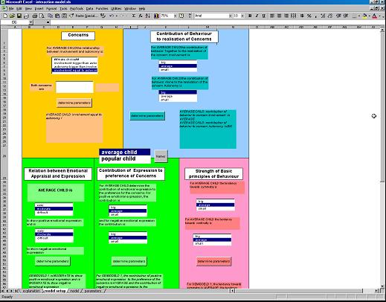

The central list box contains the names of the two model participants. Click on the button Names and specify the names of the model participants, for instance popular child and average child. Click on the name of the participant whose parameter values need to be specified, for instance popular child. Notice that the texts appearing in the colored fields now refer to the person for which the parameters will be specified.

The dark yellow field (B1 to H28) contains the parameter values referring to the Concerns. Two basic concerns are distinguished; namely Involvement and Autonomy. You can define the relative importance of one concern over the other.
The blue field (I1 to N28) contains the parameter values referring to the influence of the behavior on the realized values of the concerns Autonomy and Involvement.

The green field (B29 to K68) contains the parameter values referring to the role of Emotional Expressions. The left part of this field specifies the link between Emotional
Appraisal and Expression. For instance some children show positive Emotional Expressions more easily than others. The right part of this field contains the influence of positive and negative Emotional Expressions on the preferred values of the concerns.
The pink field (L29 to N68) contains the parameter values of the general behavioral tendencies. We distinguish the tendency towards Symmetry (to do what the other person does) and the tendency towards Continuity (to continue what you are doing yourself).
Finally, the light yellow field (B69 to N84) contains a number of more technical parameter values, namely the number of steps in the simulation, the level of randomization and the memory span.

Worksheet model

Description
- Program buttons. Click on the ‘calculate model’-button to let the model run.
- Output variable Behavior (column F and G). On the left appears the output of child 1, on the right appears the output of child 2. Playing together is colored yellow, playing alone is colored green.
- Output variable Emotional Expression (column H, I, J and K). The neutral, positive and negative expressions of child 1 appear in column H; the neutral, positive and negative expressions of child 2 appear in column I. Neutral expressions are colored light blue, positive expressions are colored red, negative expressions are dark blue. In column J and K appear the expression in numbers, ranging from + 5 (very positive) to -4 (very negative). A neutral expression has the value 0.
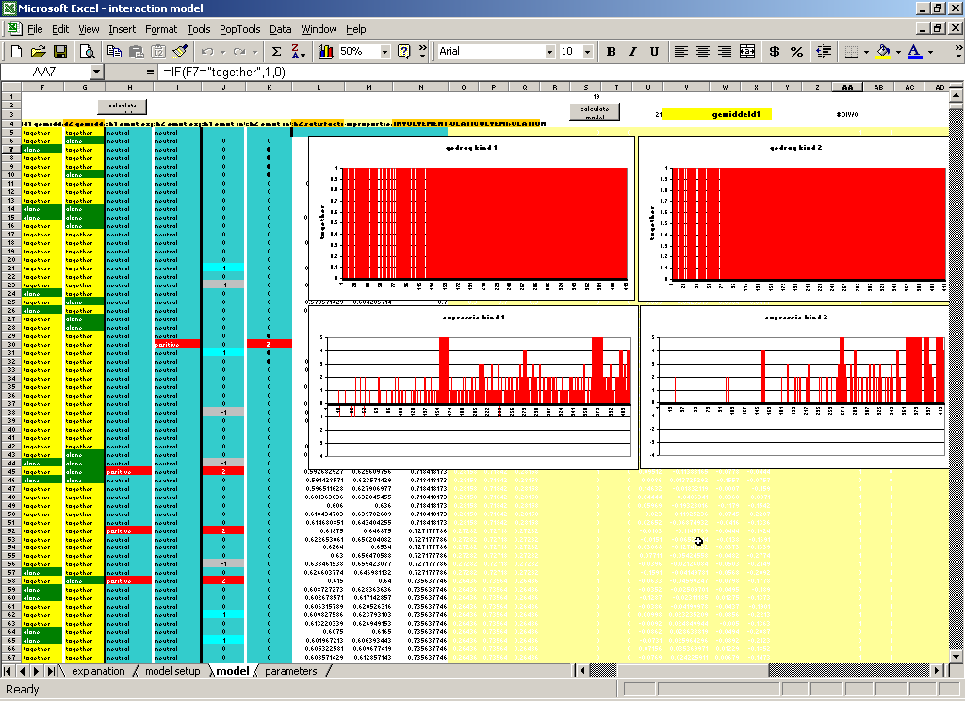
- Graphs representing the behaviors of the children. On the x-axis the time in seconds, on the y-axis the behaviors playing together or playing alone. Red indicates playing together, white indicates playing alone. Child 1 appears in the graph on the left, child 2 appears in the graph on the right.
11
11
31
41
51
21
- Graphs of the emotional expression. Neutral is white, negative is red under zero, positive is red above zero. Child 1 is represented in the graph on the left, child 2 is represented in the graph on the right

3. Applying the model to specific cases

Psychological profiles
We assume that all differences between persons that are relevant for the kind of social interaction that we wish to model can be captured in terms of the parameters we just described. In order to show how this can be done, we begin with an example of an average, socially well-adapted child, who plays with another average child.

An average, socially well-adapted child, playing with another average child

Most of the time this child prefers to play with peers instead of playing alone. This means that the child's concern for Involvement is bigger than the concern for Autonomy (dark yellow field) .
The average child can relatively easily satisfy its own goals. For instance playing together relatively easily satisfies the child's concern for Involvement. In technical terms we can state that the contribution of the child's behavior to the realization of the concerns is average (blue field).
This average child will show both positive emotions and negative emotions on a moderate level. The parameter setting for this child will be that it is moderate to show positive emotional expression and moderate to show negative emotional expression (green field left).
In general the emotions evaluate the behaviors that they accompany. For instance if playing together is accompanied by positive emotions, playing together will be valued positively. This implies that the preference for playing together will increase. The opposite occurs for negative emotions. With an average child, we assume that positive and negative emotions have the same moderate effect. In terms of parameter setting this means that the contribution of positive and negative emotional expression to the preference of the concern in question is average (green field right).
For this average child, the basic principles of behavior will be set to average. That is, the child's basic tendency to follow the actions of the peer (Symmetry) will be average, and similarly his basic tendency to continue his own actions (Continuity) will also be average (pink field).

If you want to experiment with the parameters of the average child in the model, go to the section Modeling different types of children in different contexts. We will continue with examples of different types of children.

A popular child, playing with an average child

Popularity of a child is a relational characteristic. To a considerable extent it is a property attributed to the child by its peers. This implies that the parameter values for this child will be exactly the same as for the average, socially well-adapted child.
What makes the popular child popular is the fact that the play partner will like to play with the popular child for a longer time. Thus, differences will be seen in the parameter values of the average play partner. He likes to be involved with this popular child and play together for a long time. This means that the play partner‘s concern for Involvement is much bigger than the concern for Autonomy (dark yellow field).
It also implies that he will easily be bored with playing alone; showing in the fact that playing alone relatively easily satisfies the child's concern for Autonomy. In technical terms we can state that the contribution of the child's behavior to the realization of the concern Autonomy is high (blue field). The contribution of the child's behavior to the realization of the concern Involvement is average (blue field).
The average play-partner will show positive emotional expressions on a moderate level, but will not easily show negative emotional expressions. We set the value to moderate to show positive emotional expressions and difficult to show negative emotional expressions (green field left).
With regard to the effect of emotional expressions on the preference of the concerns, remember that the default setting for the average child is that the contribution of the positive emotional expression to the preference of the concerns is average and of the negative emotional expression is also average. However, if the average child interacts with a popular child, the expressions of the popular child will be valued higher. This means that for positive emotional expression the contribution will be big, and for negative emotional expression the contribution will also be big (green field right).
The average child will also more easily follow the popular child’s actions and emotions. This implies that for the average child the tendency to imitate and follow the popular child will be stronger than average. This means that we set the tendency towards Symmetry to big. The tendency towards Continuity is average (pink field). Note that the preceding parameter settings apply to an average child playing with a popular child. The popular child’s parameters are exactly the same as those of the average child in the section An average, socially well-adapted child, playing with an average child.

A rejected child, playing with an average child

Rejection of a child is also a relational characteristic. To a considerable extent it is a property attributed to the child by his peers. What makes the rejected child rejected is the fact that the play partner will not like to play with the rejected child for a long time. Thus, differences will be seen in the parameter values of the average play partner. The play partner will have a lower tendency to play together with this rejected child. This average play partner normally will have a bigger concern for Involvement than for Autonomy. While playing with the rejected child the concern Involvement will be smaller, the setting is Involvement a little bit stronger than Autonomy (dark yellow field).
The idea (based on empirical findings) is that the rejected child really likes to play with an average play partner, something that he is not likely to do very often. Basically, he will have the same parameter values as the average child playing with a popular child.
This implies - among others - that he will have a much stronger concern for Involvement than for Autonomy and will not easily show negative emotional expressions.
Technically, it means that the rejected child's concern for Involvement is much bigger than the concern for Autonomy (dark yellow field). The contribution of the child's behavior to the realization of the concern Autonomy is high (blue field). The contribution of the child's behavior to the realization of the concern Involvement is average (blue field).
The rejected child will show positive emotions on a moderate level, but will not easily show negative emotional expressions. We set the value to moderate to show positive emotional expressions and difficult to show negative emotional expressions (green field left).
The effect of emotional expressions on the preference of the concerns will be stronger than average. This means that for positive emotional expression the contribution will be big, and for negative emotional expression the contribution will also be big (green field right).
The rejected child will also more easily follow the average play partner’s actions and emotions. This implies that for the rejected child the tendency to imitate and follow the average play partner will be stronger than average. This means that we set the tendency towards Symmetry to big. The tendency towards Continuity is average (pink field).
A subtype of the group of rejected children will more easily show aggressive behavior. This means that for this subtype the probability for negative emotional expression is high, i.e. the child will be easy to show negative expressions (green field left). This subtype will in general pay little attention to what the other child does. This means that the tendency towards symmetry is small; the tendency towards continuity is average.

Antisocial children
Various types of antisocial children can be distinguished. Let's begin with a child who would like to play with other children, implying that his concern for Involvement is bigger than for Autonomy (dark yellow field). The child has great difficulties to realize a satisfactory form of social interaction. For instance, this child shows excessive bullying behavior. The peer will probably react aversively to this behavior. This implies that what is indented as playing together is not really satisfying his concern for Involvement. Technically this means that the contribution of the behavior to the realization of the concerns is small (blue field).
A bully will easily show negative emotional expression, and be difficult to show positive emotional expression (green field left). Because the bully evaluates the play partner only in function of the bullying, the social evaluation assigned to the play session is low. Both positive and negative emotional expression probably have a small effect on the preference for the concerns (green field right).
He will have a big tendency towards Continuity and a small tendency towards Symmetry (pink field).

Compare this with another form of antisocial behavior, which is of the autistic type. A proverbial autistic child will have a very strong tendency for playing alone. At the same time the child needs to be alone for a long time in order to realize this concern even at a minimal level. Thus the concern is set to Autonomy much bigger than Involvement (dark yellow field). The autistic child is very quickly satisfied with playing together, which implies that the contribution of the behavior to the concern Involvement is very high. On the other hand, the concern playing alone is very difficult to satisfy, and thus the contribution of the behavior to the concern Autonomy is very low (blue field). This child is difficult to show both positive and negative emotional expression (green field left). We expect a high level of rigidity in the concerns, which implies that the influence of the emotional expressions on the preference for the concerns is small, for both the positive and the negative emotions.
This child will have a big tendency towards continuity and a small tendency towards symmetry.

Note that the menu structure is set up with the intention of modeling various prototypes of children. In order to model more variants of these prototypes or more extreme types of children, the parameter values based on menu options must be manually altered. This can be done in the worksheet parameters. Note that there are three sets of predefined values specifying a popular, an average and a rejected child playing with an average child. The predefined sets can be inserted in the parameter field by means of three buttons.

Modeling various types of children in different contexts

Setting the parameters

We will model the interaction between a popular and an average child.
Go to the worksheet model setup. Set the zoom factor to 75% (in the menu click on view / zoom / 75%, ok). Save the file under a different name.
Click on the central button Names.
In the first input box type popular child. Then ok
In the second input box type average child. Then also ok.
Now we are going to fill in the boxes, for each child separately.

Concerns
In the central name window click on popular child.
Go to the dark yellow field. Click in the text box on involvement bigger than autonomy. In the second text box activate bigger than. Finally click on the button determine parameters. The text under the button will now contain the message popular child: involvement bigger than autonomy / bigger than.
Each time you click on a determine-parameters- button the text will change and specify your choice.
Go to the central name box and specify the second child: click on average child.
Go back to the dark yellow field. Activate involvement bigger than autonomy. Then much bigger than. Click on determine parameters.

Contribution of behavior to realization of concerns
Go to the central name box and click on popular child. Go to the blue field on the right. In the upper text box click on average.
In the lower text box also average.
Then determine parameters.
In the central name box, activate average child. Go again to the blue field.
In the upper text box click on average.
In the lower text box big.
Then determine parameters.

Relation between emotional appraisal and expression
Go back to the central name box and click on popular child. Go to the green field left.
Fill in that for the popular child it is moderate to show positive emotional expression, and that it is moderate to show negative emotional expression.
Then determine parameters.
In the central name box, activate average child. Repeat the above mentioned steps: fill in that for the average child it is moderate to show positive emotional expression, and that it is difficult to show negative emotional expression.

Contribution of expression to preference of concerns
Go back to the central name box and click on popular child. Go to the green field right.
Activate average in the upper text box and average in the lower text box. Then determine parameters.
In the central name box, activate average child. Activate big in the upper text box and big in the lower text box. Then determine parameters.

Strengths of basic principles of behavior
Go back to the central name box and click on popular child. Go to the pink field right.
Activate average in both text boxes. Then determine parameters
Click on average child in the central name box.
Activate big in the upper text box (tendency towards Symmetry), activate average in the lower text box (tendency towards Continuity).
Then determine parameters.

Scroll to the light yellow field in the bottom. Set the number of steps in the simulation on 420. If every step counts for one second, for instance 420 steps corresponds with a time span of seven minutes. Seven minutes was exactly the time span of our empirical data of play sessions of two children. Set the level of randomization to average and the memory span to medium, then determine parameters.

Patterns of behavior and emotional expression.

Activate the worksheet model.
Click on the button calculate model.
To read the output of the model, first inspect the columns with the behavioral output. A simple way to look at the behavioral output is to look at the behavior graphs (number 4).

Question: Describe the pattern in terms of play activities. Remember that each graph represents that particular child’s behavioral contribution to the play pattern, in terms of playing alone or playing together. To what extent is the behavior of one child coherent with the behavior of another, e.g. are they playing together at the same time?

Second, inspect the graphs of the emotional expression (number 5).

Question: What pattern of expression do the children show in the play session? For instance, does the level of expression increase or decrease? Is it primarily positive or negative? Is this a realistic pattern for the playing of a popular and an average child?
Compare the patterns of behavior with the patterns of emotional expression. Do you see any coherence or relationship?

We will now inspect the effect of repeated runs of the model. Each repeated run recalculates the model on the basis of the original parameter values, but with different random influences.

Question: Look at the pattern of the emotional expressions and in particular the amount of positive expressions versus negative expressions. The averages appear in text boxes in the graphs. Look at the distribution of expressions, e.g. are there more positive expressions towards the end? Do this for the two children separately.
Repeat the model run 10 times and characterize the properties of each run. Are there major differences between the 10 runs? If so, what are the most salient differences?
Try to give an interpretation of these differences in terms of actual play situations.
Do the same exercise with the properties of the behavioral variable.

Constructing a parameter profile for a play partner.

As a final assignment try to model the interaction between an average and an antisocial child. Use one of the descriptions given in the section heading psychological profiles / antisocial children. Try to develop a reasonable collection of parameter settings for the average play partner of this antisocial child. Remember that the parameter settings of the play partner are quite strongly determined by the child’s interpretation and evaluation of the play situation.

Question: Describe the patterns of behavioral and emotional expression that your model produces. Do you consider them realistic for the kind of play situation you have tried to model?

References
Frijda, N.H. (1986). The emotions: studies in emotion and social interaction. Cambridge: Cambridge University Press.

Frijda, N.H. (2001). The self and emotions. In: Bosma, H.A, & Kunnen, E.S. Identity and emotion: development through self-organization. Cambridge: Cambridge University Press

The chosen parameter set is an approximation of the profile at issue. The important thing is the collection of contrasts in a particular parameter setting. Many variants of a profile are possible, as long as contrasts are maintained.

