The intrinsic dynamics of development

  - Paul van Geert
  - Marijn van Dijk

Authors affiliation: The Heymans Institute, Grote Kruisstraat 2/1, 9712 TS Groningen, the Netherlands

Abstract
In this article we discuss an emergent developmental science. It provides an approach to development that redefines its theoretical and methodological basis in the general theory of complex dynamic systems. Its methodological research choices are in line with a focus on actual developmental processes, as they occur in individual cases, such as individual children, families, or relationships. Intra-individual variability based on frequent short-term as well as long-term measurements provides an important source of information. Theoretically, we advocate a model of a network of dynamically interacting components, generating a wide variety of developmental trajectories, in line with the idiosyncratic nature of developmental systems.

Towards a new foundational theory for development
The word development - or de-velopment - literally means unwrapping. In whatever it is that develops, there is some hidden thing that can be uncovered by removing the wraps, the wraps metaphorically referring to anything that hides the essence that will be uncovered. This view on development is rooted in ancient philosophy, and in particular in the Aristotelian notions of potentiality. Potentiality is defined as the range of possibilities of something, given the way this thing works, or a possible actuality in the future. Actuality is defined as being at work here and now, and entails directivity inherent in the way this thing or phenomenon is "at work".
This ancient view on potentiality is in a sense revitalized by the modern (meta-) theory of complex dynamic systems, which has served as a basis for our own work in developmental psychology. A complex dynamic system can be defined as a system consisting of many components or elements that interact with one another, often on the basis of quite simple interaction principles. These components change over short- as well as long-term time spans because of their interactions with other components. Typically, these changes are self-organizing and are coordinated in the form of emergent properties. An emergent property is a new property of the system, spontaneously originating out of the interactions, not present in any of its parts and in general not reducible to some sort of sum of the parts. For instance, a child’s development of the ability for abstract thinking, or for understanding psychological states of other people (theory of mind), are examples of emergence and emergent phenomena, unless we see these abilities as simple collections of skills that were already present. There is very little evidence for the latter assumption (Fischer & Bidell, 2006).
Emergence is a form of actualizing the potentiality of the system, with the potentiality given in the changing structure of interactions between the components. An increasing number of studies is supporting the view that the development of a child in his or her social and cultural context can be conceived of as a complex dynamic system. Examples from our own work concern language development (Van Geert, 1991; Van Dijk et al. 2013), feeding and eating (Van Dijk, Hunnius & Van geert, 2013), early scientific reasoning (Van der Steen et al., 2014), play and social interaction (Steenbeek & Van Geert, 2010, 2011, 2014), identity and self-esteem (Lichtwarck-Aschoff et al., 2010), emotions and conflicts in adolescence (Lichtwarck et al., 2009), adolescent friendship formation (Schuhmacher et al., 2014), teacher-child interaction (Steenbeek & Van Geert, 2013), special education (Steenbeek et al, 2011) and developmental theory formation (Van Geert, 1991, 1998, Van Geert & Steenbeek, 2005).
The assumption of complex dynamic systems as the foundational theory for development has various consequences for the kinds of research and theory formation that should be done in developmental psychology.
However, current developmental psychology hardly has anything like an overarching theory of development, consisting of a set of first principles or basic mechanisms of development. The picture that emerges from what is probably still the main practice of research is that development can be described as a broad connection of phenomena, such as attachment, the child's theory of mind, bullying, executive functioning and so forth, that are under the control of a comparably wide variety of independent variables. For many researchers, "explain" still basically means to reduce the inter-individual variability of a particular phenomenon across the population to the inter-individual variability in a set of other variables. Current developmental psychology is now slowly moving away from being a-theoretical and is looking more and more into the dynamics of change.

Emerging trends in developmental theory formation and research
There are two important issues on how to explain and study development, which are now undergoing a radical revision.
The first issue deals with the meaning of intra-individual variability, i.e. fluctuations and changes in the way developing persons carry out particular activities that refer to underlying psychological variables, such as a child's mastery of syntax, its understanding of theory of mind, its reasoning in science and technology problems and so forth. A related issue deals with the question of whether models based on studying groups (representative samples) can tell us anything about individual trajectories.
The second issue deals with the basic mechanisms of development, namely how particular variables can be said to explain various developmental phenomena.

Intra—individual variability and individual developmental trajectories
Individual development is hardly ever a regular – linear or stepwise – process. Although some general order obviously exists across children (for instance when learning how to walk, they go through roughly the same ‘stages’), a much more irregular – almost chaotic – picture emerges when looking at individual pathways (for instance, infants use many different strategies of locomotion at the same time, and show temporal improvements as well as regressions). When reviewing the literature on early development, it becomes clear that this type of (intra-individual) variability is prominent in various domains, for instance in motor and mental development (e.g. Freedland & Bertenthal, 1994; McCall, Eichorn, & Hogarty, 1977; for a thorough review see Van Dijk & Van Geert, 2014). However, though intra-individual variability is a rather universal finding, its importance has not been recognized for a long time. The reason for this is that intra-individual variability is (traditionally) conceived of as being merely a reactive phenomenon. The moment-to-moment irregularities are seen as the result of context changes, which are considered to be independent of development. A more methodological traditional explanation for variability is that it is caused by measurement error. This interpretation originates from true score theory (Cronbach, 1960; Lord & Novick, 1968; Nunnally, 1970), which states that each observed psychological score is the result of both a ‘true score’ plus an ‘error term’. Thus, although behavior may look irregular because of ‘noise’, the underlying latent variables (the psychological constructs) are considered to be rather stable. These viewpoints (context dependency an measurement error) largely overlap, but the difference is that the measurement error concept frames it in terms of psychological measurement, and thus offers a methodological solution, which is averaging over the irregularities.
With the emergence of the theoretical framework of complex dynamic systems in psychology, a new view on variability was put forward, which was that variability should be seen as a driving force of development (Lewis, 2000; Thelen & Smith, 1994; van Geert; 1994; Van Geert & Van Dijk, 2002). This theoretical approach defined development as a self-organizing system of many components that constantly interact with each other and the environment. Variability was argued to reflect a system’s flexibility, and to offer the system room for exploration. According to this theory, variability is seen a generator of change by means of Darwinian principles of variation and selection (Thelen, 1985). This idea was already introduced with the theorem of operant conditioning by Skinner (1937), which states that learning is critically dependent on the consequences of the of the individual’s intrinsically variable behaviors. In this sense, variability is a precondition for development because it enables the individual to adapt to new situations. Within a particular developmental system, structural reorganizations occur at transition points, periods of instability where old patterns break down and new ones emerge (Lewis, 2000). Variability is important because its presence can be used to detect these transition points (Granott, Fischer & Parziale, 2002). Studying intra-individual variability can thus provide insight into how the system is changing.
Already in 1994, Thelen and Smith urged developmental psychologists to treat intra-individual variability as data and to use it in their analyses, instead of averaging it out by means of smoothing techniques. In the two decades that have followed, more and more researchers have started to act accordingly and have started to take variability seriously. Innovations in computation and software have been a driving force in this development. Many methods have been developed with regard to data analyses and description and have been applied to a wide variety of topics in human development, for instance in the domain of motor coordination (by authors such as Thelen, Ulrich, and Smith), cognitive and language development (by authors such as van Geert, Fischer, Case, and Granott,) and emotional/social development (by for instance Fogel, Granic, and Lewis).
Studying intra-individual variability requires taking repeated measures of the same behavior across time, and the time scale of measurement must be able to both fit the real-time behaviors and to capture long-term change. A highly suitable approach to study the relations between these time scales is offered by the microgenetic method (Flynn & Siegler, 2007; Lavelli, Pantoja, Hsu, Messinger, & Fogel, 2006). This method considers fine-grained information of real-time behavior essential for grasping macro-level change processes (Lavelli et al., 2006; Siegler, 2006).
In order to analyze patterns of variability, some simple descriptive techniques have been proposed, such as the moving min/max graph, the skewness-analysis and peak analysis (van Geert & van Dijk, 2002; van Dijk and van Geert, 2007). Other measures are developed to describe qualitative variability of interaction behaviors. For instance, Lewis and colleagues (Hollenstein, 2013; Lewis, Lamey, & Douglas, 1999) developed the State Space Grid (SSG) method which has become increasingly popular in a broad domain of developmental research, such as parent-child interactions, (see for instance Hollenstein, Granic, Stoolmiller, & Snyder, 2004; van Dijk, Hunnius & van Geert, 2012), teacher-child interaction (Mainhart, Pennings, Wubbels, & Brekelmans, 2012) and young children’s peer relationships (Martin, Fabes, Hanisch, & Hollenstein, 2005).
In addition to focusing on its frequency or magnitude, variability can also be analyzed in terms of its structure. Methods employing tools from the field of nonlinear dynamics – such as fractal and spectral analysis – can be used to classify patterns in terms of pink noise. Pink noise is also called 1/f scaling, and consists of a wavy, a-periodic, fractal pattern which is considered to be the signature of self-organization. Other promising methods are offered by Recurrence Quantification Analysis (RQA) and Cross-RQA which can also be used to detect transitions in the temporal structure of a pattern (Marwan, Romano, Thiel, & Kurths, 2007; Marwan, 2008; Webber & Zbilut, 2005). These methods offer measures that express the degree of determinism/flexibility in time series. Although these techniques are rather new in the field of human development, they have been successfully applied to a variety of topics, such as syntactic coordination during language development (Dale & Spivey, 2006), reading in dyslexia (Wijnants et al, 2012), motor control (Wijnants, Bosman, Hasselman, Cox, & Van Orden, 2009), and problem solving behavior (Kloos & van Orden, 2009).
When studying patterns of intra-individual variability, questions of a more fundamental nature also arise. One of the most notable findings from developmental studies that are based on time series is that individual development is idiosyncratic. This finding leads us to the question of how we can generalize from these highly individualized patterns to more general knowledge about developmental processes. In relation to this, Molenaar and Campbell (2009) have argued that developmental models based on aggregated group data do – by definition – not apply to individual processes, because of the non-ergodic nature of these processes. In relation to this, the meaning of the concept of ‘generalization’ should also be reconsidered. Currently, generalization is mainly viewed in terms of ‘sample generalization’ of explained variance in a sample (see van Geert, 2011). However, we have argued before that generalizability should be conceived in terms of how individual development relates to an underlying developmental theory (van Geert, 2011).

Explaining development
How can development be explained? Let us focus on a single variable or dimension of development, such as a child’s frequency of use of nouns in its sentence constructions, a child’s level of reasoning in science problems, a child’s motivation to focus on a particular type of school task and so forth. Suppose we would have studied a representative sample of children and found a positive correlation between age and the level of reasoning. It is tempting to interpret this correlation as evidence for a linear relationship between age and reasoning. That is, with every unit increase in age, we may assume a corresponding unit increase in level of reasoning. If the sample is big enough and really representative of the population of children, we might be tempted to treat this linear model as a general model of reasoning growth, and assume that, since it is a general model, it must apply to every individual child in the population of interest. Treated as a model of individual change, the correlation basically suggests that the next state of the variable “level of reasoning” is equal to the preceding state plus some constant value that is characterized by a certain level of stochastic variation:
y_{t+1} = y_{t} + a +e
or, in the form of the change formula
∆y/∆t = a
However, the time serial data we have on individual change processes hardly if ever show this sort of overall simple linear increase. Individual change processes are characterized by various patterns of change, such as S-shaped change, inverted J-shaped change, discontinuous change, stepwise changes, inverted U-shaped change, overlapping waves, changing variability, temporary regressions, or stepwise changes each of which is preceded by temporary regression (e.g. Van Geert, 1998 for an overview). What we should do now is to try to define mathematical expressions for the iterative change pattern that, first, correspond with theoretically feasible causal principles of developmental change and, second, generate the developmental patterns found in individual trajectories (Van Geert, 1991, 1994; Van Geert & Steenbeek, 2005).
The first principle that such growth models entail is that the amount of change depends on what is “already there”, i.e. is proportional to the current level of the variable.
y_{t+1} = y_{t} + y_{t} . a
or in the form of the change formula
∆y/∆t = y.a
A second general principle of growth is that it depends on intrinsically limited resources. That is, as a variable approaches the limit set by the limited resources, growth will decline in a way that is proportional to the level already attained. Both principles can be combined into the logistic growth equation (it was first discussed in the context of population growth by the 19th century Belgian mathematician Verhulst):

y_{t+1} = y_{t} + y_{t} . r . ( 1 – y_{t} / K)

(for K being a limiting factor corresponding with the set of available resources).
The change in a variable also depends on the influence from other variables, for instance, acquisition of syntax depends to a greater or lesser extent on the quality and availability of syntactic “input” from the environment, but also on the presence of a critical mass of words in early language development (e.g. Marchman & Bates, 1994). In line with the general assumption that growth depends on what is already there, the effect of other variables, can be represented as follows:
∆y/∆t = v_{i}.y.s_{i}
(for s being an influencing factor which can be positive, in which case we call the variable v_{i} a supportive variable, and a competitive variable in case the value is negative).
In a growth process, a variable may affect another one not by its level but by the amount it changes, i.e. its increase or decrease. For instance, the increase of a particular variable, such as a child’s knowledge of multiplication and division, may consume shared resources such as practice time or effort at the time this particular knowledge is explicitly taught or practiced by the child (Fischer and Bidell, 2006). In this case, the effect of the variable v on the variable y occurs via its first derivative, and can be written as
∆y/∆t = ∆v_{i}.y.w_{i}
(for w a parameter that can again be supportive or competitive i.e. positive or negative).

Finally, , variables can be connected in various ways and connections can be reciprocal, symmetrical or asymmetrical. For instance, the level of a particular skill can be positively affected by skill-specific motivation, but on the other hand the skill specific motivation can be positively (symmetrically) or negatively (asymmetrically) affected by the level already attained. The relationships can in principle also be indirect, as when a particular skill positively affects the increase in motivation that affects the growth of another skill, which then positively or negatively affects the first skill.
Such connections can in principle be highly idiosyncratic, i.e. typical of a particular individual, for instance during the development of specific interests in children. However, some connections are highly systematic, particularly in educational contexts. Education often takes place in the form of highly regulated forms of interactions between adults and children, or between teachers and students. The teacher will adapt his or her level of help and instruction – for instance with regard to science reasoning — to the needs of the students, that is to say, to the level, for instance of science reasoning, the students have already attained. This adaptation is meant to facilitate the students’ learning. Adaptation and learning thus become a coupled process of mutual fine-tuning. This process can be described in the form of coupled dynamic equations for learning-teaching processes in general (Van Geert & Steenbeek, 2005), and for processes of child-directed speech and language acquisition (Van Dijk et al., 2013).
The general point is that the variables describing a complex developing system are, in principle, connected in a wide variety of ways. That is, such a complex system can be described by a network of interacting variables, the interactions of which are described in the form of theoretically generalized growth equations (Van Geert et al., submitted).

Insert figure 1 with examples of resulting temporal patterns about here

It is likely that the networks of interacting variables characterizing developmental systems have a network structure comparable to that of a small world networks (Van Geert et al., submitted). That is to say, the number of direct dynamic connections between any two variables is relatively small, but any variable is likely to be associated with any other variable in an indirect way, i.e. via a few intermediary, directly connected variables. Small world properties can be found in a large variety of networks, including the pattern of connectivity in the brain (Bullmore and Sporns, 2009).
It is interesting to observe that the network model governed by the above equations naturally produces a wide variety of temporal trajectories that show many of the qualitative phenomena that have been described in the literature (Fischer and Van Geert, 2013; Van Geert et al., submitted). It generates sequences of S-shaped growth, stepwise growth, temporal regressions, inverted U-shaped growth, long-term couplings between variables, and sequences of overlapping waves. In addition, the model generates predictions for the distribution of exceptional (excellent) performance levels, which are not symmetrically distributed and are in fact highly skewed (Simonton, 2000). The model generates developmental trajectories in which the predictability of the final level of a particular developmental variable or ability increases with age. It also predicts that heritability, defined as a correlation with genetic endowment, increases with increasing age, as is demonstrated by empirical data.

The study of network models of development has great promise for the future, but many problems have yet to be solved. One question concerns a shift in explanatory emphasis. Standard models, based on inter-individual variability obtained over big representative samples of individuals, typically focus on component-dominant forms of explanation. That is to say, they try to explain the variance of a particular phenomenon across individuals by estimating the independent contributions of major variables or components, for instance the contribution of the variable “intelligence” to the variable “school performance”. Network models, however, focus on explaining how dynamic interactions between many directly and indirectly connected variables generate highly specific patterns of intra-individual variability, for instance in indicator variables such as reaction time in reading (Wijnants, Hasselman, Cox, Bosman & Van Orden, 2012), or moment-to-moment emotional and behavioral expressions of self-esteem (de Ruiter-Wilcox et al., submitted). Another question concerns the as yet unsolved tension between self-organization either into stable attractors or into critical states. A stable attractor is a self-sustaining stable state of the system, for instance, a child using a particular strategy to solve a broad range of problems, irrespective of whether the strategy leads to correct solutions are not. A critical state is one in which the system moves towards a particular form of instability, where a relatively minor experience or event may cause the system to rapidly change towards a new attractor state. Theorists such as Piaget already had the intuition that a developing system changes in the form of a succession of states (Piaget’s famous stages). Each stage, with the exception of the final one, automatically moves towards a point of instability, where relatively minor events cause it to rapidly reorganize into a different pattern, i.e. a different developmental stage. This type of process is very similar to what the theory of self-organized criticality (Bak, 1996) would predict, but the empirical data for verifying its existence in long-term developmental changes still need to be collected. On the other hand, analyses of the fractal structure of time-serial patterns in developing systems have demonstrated properties such as self-similarity over various time scales, which also comply with the mechanism of self-organized criticality.

Developmental psychology: an emergent science of emergence
The emerging trend that we discussed in this article concerns the emergence of a new kind of developmental science: it is new in the sense that it redefines its basis in the general theory of complex dynamic systems, and new in the sense that it redefines its methodological research choices in line with a focus on actual developmental processes, as they occur in individual cases, such as individual children, families, or relationships.

References
Barr, R.G.( 1990), The normal crying curve: What do we really know? Developmental Medicine & Child Neurology, 32, 356-362.
Bassano, D. & van Geert, P. (2007). Modeling continuity and discontinuity in utterance length: a quantitative approach to changes, transitions and intra- individual variability in early grammatical development. Developmental Science 10, 588–612.
Bornstein, M. H. & Tamis-LeMonda, C. S. (1990). Activities and interactions of mothers and their firstborn infants in the first six months of life: Covariation, stability, continuity, correspondence, and prediction. Child Development, 61, 1206-1217.
Bullmore, E., & Sporns, O. (2009). Complex brain networks: graph theoretical analysis of structural and functional systems. Nature reviews. Neuroscience, 10(3), 186-98.
Dale, R. & Spivey, M. J (2006). Unraveling the dyad: using recurrence analysis to explore patterns of syntactic coordination between children and caregivers in conversation. Language Learning, 56, 391-430.
De Graag, J. A. Cox, R. F.A. Hasselman, F., Jansen, J. & de Weerth, C.(2012). Functioning within a relationship: Mother–infant synchrony and infant sleep. Infant Behavior and Development, 35, 252-263.
De Ruiter-Wilcox, N., den Hartigh, J.R., Cox, R.F.A. , Van Geert, P.L.C & Kunnen, E.S. (submitted). The temporal structure of state self-esteem variability during parent-child interactions: more than random fluctuations.
Fischer, K. W., & Bidell, T. R. (2006). Dynamic development of action and thought. In W. Damon & R. M. Lerner (Eds.), Theoretical models of human development: Handbook of child psychology (6th ed., Vol. 1, pp. 313–399). New York: Wiley.
Fischer, K.W. & Van Geert, P.L.C. (2014). Dynamicv development of brain and behavior. In P.C.M. Molenaar, Lerner, R.M. & Newell, K. M. (Eds.). Handbook of Developmental Systems Theory & Methodology. New York: The Guilford Press, pp. 287-315.
Flynn, E. & Siegler, R. (2007). Measuring change: Current trends and future directions in microgenetic research. Infant and Child Development, 16, 135-149.
Freedland, R. L. & Bertenthal, B. I. (1994). Developmental changes in interlimb coordination: Transition to hands-and-knees crawling. Psychological Science, 5, 26-32.
Granott, N., Fischer, K. W., & Parziale, J. (2002). Bridging to the unknown: A transition mechanism in learning and development. In N. Granott & J. Parziale (Eds.), Microdevelopment: Transition processes in development and learning (pp. 1–28). New York, NY: Cambridge University Press.
Hollenstein, T. (2013). State space grids: Depicting dynamics across development. New York, NY: Springer.
Hollenstein, T., Granic, I., Stoolmiller, M., & Snyder, J. (2004). Rigidity in parent-child interactions and the development of externalizing and internalizing behavior in early childhood. Journal of Abnormal Child Psychology, 32, 595-607.
Kloos, H. & Van Orden, G.C. (2009). Soft-assembled mechanisms for the grand theory. In J.P. Spencer, M. Thomas, & J. McClelland (Eds.), Toward a New Grand Theory of Development? Connectionism and Dynamics Systems Theory Reconsidered, (pp. 253- 267). Oxford University Press.
Lavelli, M., Pantoja, A. P. F., Hsu, H., Messinger, D., & Fogel, A. (2006). Using microgenetic designs to study change processes. In D. M. Teti (Ed.), Handbook of research methods in developmental science (pp. 40-65). Malden, MA: Blackwell Publishing.
Lewis, M. D. (2000). The promise of dynamic systems approaches for an integrated account of human development. Child Development, 71, 36-43.
Lewis, M. D., Lamey, A. V., & Douglas, L. (1999). A new dynamic systems method for the analysis of early socioemotional development. Developmental Science, 2, 458-476.
Lichtwarck-Aschoff, A., van Geert, P., Bosma, H., & Kunnen, S. (2008). Time and identity: A framework for research and theory formation. Developmental Review, 28(3), 370-400.
Lichtwarck-Aschoff, A., Kunnen, S. E., & van Geert, P. L. (2009). Here we go again: A dynamic systems perspective on emotional rigidity across parent–adolescent conflicts. Developmental psychology, 45(5), 1364.
Lichtwarck-Aschoff, A., Hasselman, F., Cox, R. Pepler, D. & Granic, I. (2012). Characteristic Destabilization Profile in Parent-Child Interactions Associated with Treatment Efficacy for Aggressive Children. Nonlinear Dynamics, Psychology, and Life Sciences, 16, 353-379.
Lord F. M. & Novick, R. (1968). Statistical theories of mental testscores. Reading, Mass: Addison-Wesley.
Mainhard, M. T., Pennings, H. J. M., Wubbels, T., & Brekelmans, M. (2012). Mapping control and affiliation in teacher–student interaction with state space grids. Teaching and Teacher Education, 28, 1027-1037.
Marchman, V. A., & Bates, E. (1994). Continuity in lexical and morphological development: A test of the critical mass hypothesis. Journal of child language,21, 339-339.
Martin, C. L., Fabes, R. A., Hanish, L. D., & Hollenstein (2005). Social dynamics in the preschool. Developmental Review, 25, 299–327.
Marwan, N. (2008). A Historical Review of Recurrence Plots. European Physical Journal, 164, 3–12.
Marwan, N., Romano, M. C. ,Thiel, M. ,Kurths, J. (2007). "Recurrence Plots for the Analysis of Complex Systems". Physics Reports 438 (5–6), 237–329.
Molenaar, P. C. M., & Campbell, C. G. (2009). The new person-specific paradigm in psychology. Current Directions in Psychological Science, 18(2), 112–117.
Rovine, M. J., Sinclair, K. O., & Stifter, C. A. (2010). Modeling mother-infant interactions using hidden Markov models. In K. Newell & P. C. M. Molenaar (Eds.), Individual pathways of change in learning and development (pp. 51-67). Washington, DC: American Psychological Association.
Schumacher, N., Ballato, L. & Van Geert, P. (2014). Using an agent- based model to simulate the development of risk behaviors during adolescence. Journal of Artificial Societies and Social Simulation, 17 (3).
Siegler, R. S. (2006). Microgenetic analyses of learning. In W. Damon & R. M. Lerner (Series Eds.) & D. Kuhn & R. S. Siegler (Vol. Eds.), Handbook of child psychology: Volume 2: Cognition, perception, and language - 6th edition (pp. 464–510). Hoboken, NJ: Wiley.

Simonton, D. K. (2001). Talent development as a multidimensional, multiplicative, and dynamic process. Current Directions in Psychological Science, 10, 39-43.
Skinner, B. F. (1937). Two types of conditioned reflex: A reply to Konorski and Miller. Journal of General Psychology, 16, 272-279.
Steenbeek, H., Jansen, L., & van Geert, P. (2012). Scaffolding dynamics and the emergence of problematic learning trajectories. Learning And Individual Differences, 22(1), 64-75 .
Steenbeek, H., & Van Geert, P. (2008). An empirical validation of a dynamic systems model of interaction: do children of different sociometric statuses differ in their dyadic play? Developmental Science, 11(2), 253-281.
Steenbeek, H., & van Geert, P. (2013). The emergence of learning-teaching trajectories in education: a complex dynamic systems approach. Nonlinear dynamics, psychology, and life sciences, 17(2), 233-267.
Tamis-LeMonda, C. S. & Bornstein, M. H. (1991). Individual variation, correspondence, stability, and change in mother and toddler play. Infant Behavior & Development, 14, 143-162.
Thelen, E. & Smith, L. B. (1994). A dynamic systems approach to the development of cognition and action. Cambridge, Mass: MIT-Press.
Thelen, E. (1985). Developmental origins of motor coordination: Leg movements in human infants. Developmental Psychobiology, 18, 1-22.
Van Der Steen, S., Steenbeek, H., Van Dijk, M., & Van Geert, P. (2013). A process approach to children's understanding of scientific concepts: A longitudinal case study. Learning and Individual Differences.
Van Dijk, M., & Van Geert, P. (2007). Wobbles, humps and sudden jumps: A case study of continuity, discontinuity, and variability in early language development. Infant and Child Development, 16, 7-33.
Van Dijk, M., & Van Geert, P. (2014). The Nature and Meaning of Intra-individual Variability in Development in the Early Life Span. In M. Diehl, K. Hooker and M. Sliwinski (Eds.), Handbook of Intra-individual Variability across the life span. New York: Taylor & Francis/Routledge (in press)
Van Dijk, M., Hunnius, S. & van Geert, P (2012). The dynamics of feeding during the introduction to solid food. Infant Behavior and Development, 35, 226-239.
Van Dijk, M.; van Geert, P.; Korecky-Kroell, K.; Maillochon, I.; Laaha,; S. Dressler W.U. & Bassano, D. (2012). Adaptation between child directed speech and early child language; a developmental perspective. Manuscript accepted for publication. Language Learning.
Van Geert, P., den Hartigh, J.R., Steenbeek, H.W. & Van Dijk, M. (submitted). The Development of Expertise and Exceptional Performance: A Dynamic Network Model.
Van Geert, P. & Van Dijk, M. (2002). Focus on Variability, new tools to study intra-individual variability in developmental data. Infant Behavior and Development, 25, 340-374.
Van Geert, P. & Steenbeek, H. (2005a). The dynamics of scaffolding. New Ideas in Psychology, 23(3), 115–128.
Van Geert, P. and Steenbeek, H. (2005b). Explaining after by before. Basic aspects of a dynamic systems approach to the study of development. Developmental Review, 25 (3-4), 408-442.
van Geert, P. (1986). Theory building in developmental psychology. Amsterdam: Elsevier.
van Geert, P. (1991). A dynamic systems model of cognitive and language growth. Psychological Review, 98, 3–53.
Van Geert, P. (1994). Dynamic systems of development: Change between complexity and chaos. New York: Harvester Wheatsheaf.
Van Geert, P. L. C. (1998). A dynamic systems model of basic developmental mechanisms: Piaget, Vygotsky and beyond. Psychological Review, 105(4), 634–677.
Van Geert, P. (2011). The contribution of complex dynamic systems to development. Child Development Perspectives, 5(4), 273-278.
Van Geert, P. L. C. and Fischer, K. W. (2009). Dynamic systems and the quest for individual-based models of change and development. In J. P. Spencer, M. S. C. Thomas, & J. McClelland (Eds.), Toward a unified theory of development: Connectionism and Dynamic Systems Theory re-considered (pp. 313-336). Oxford: Oxford University Press.
Van Geert, P., & Steenbeek, H. (2005a). Explaining after by before: Basic aspects of a dynamic systems approach to the study of development. Developmental Review, 25(3), 408-442.
Van Geert, P., & Steenbeek, H. (2005b). The dynamics of scaffolding. New Ideas in Psychology, 23(3), 115-128.
Van Geert, P., & van Dijk, M. (2002). Focus on variability: New tools to study intra-individual variability in developmental data. Infant Behavior and Development, 25, 340-375.
Van Geert, P.L.C. and Fischer, K.W. (2009). Dynamic systems and the quest for individual-based models of change and development. In J.P. Spencer, M. S. C. Thomas, & J. McClelland (Editors), Toward a New Grand Theory of Development? Connectionism and Dynamic Systems Theory Reconsidered. Oxford: Oxford University Press. Pp. 313-336.
Webber Jr., C. L., & Zbilut, J. P. (2005). Recurrence quantification analysis of nonlinear dynamical systems. In M. A. Riley & G. C. Van Orden (Eds.), Tutorials in contemporary nonlinear methods for the behavioral sciences (pp. 26-94). Washington, DC: National Science Foundation.
Wijnants, M. L., Bosman, A. M. T., Hasselman, F., Cox, R. F. A., & Van Orden, G. C. (2009). 1/f scaling in movement time changes with practice in precision aiming. Nonlinear Dynamics, Psychology, and Life Sciences, 13, 79-98.
Wijnants, M. L., Hasselman, F., Cox, R. F. A., Bosman, A. M. T., & Van Orden, G. C. (2012). An interaction-dominant perspective on reading fluency and dyslexia. Annals of Dyslexia, 62, 100-119.
Worobey, J. & Blajda, V. M. (1989). Temperament ratings at 2 weeks, 2 months, and 1 year: Differential stablity of activity and emotionality. Developmental Psychology, 25, 257-263.

Figures
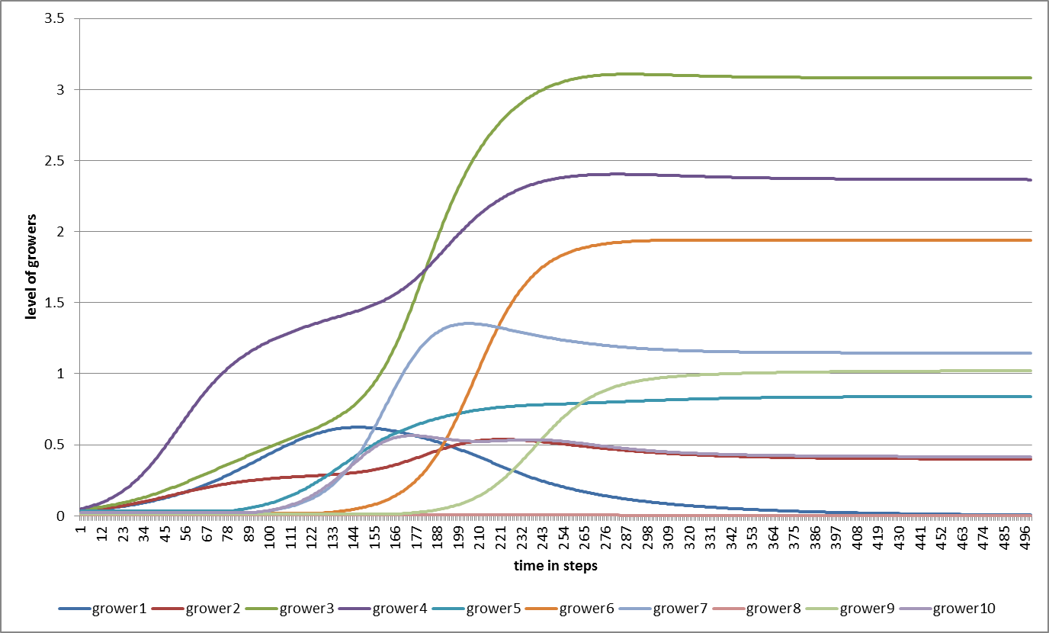
Figure 1a: A typical outcome of a network model of 10 connected growers, representing 10 variables from a developing system. Trajectories show simple S-shaped forms (e.g. grower 3), stepwise change (e.g. grower 4), inverted-U-shape (e.g. grower 1), and temporal overshoot (e.g. grower 5).

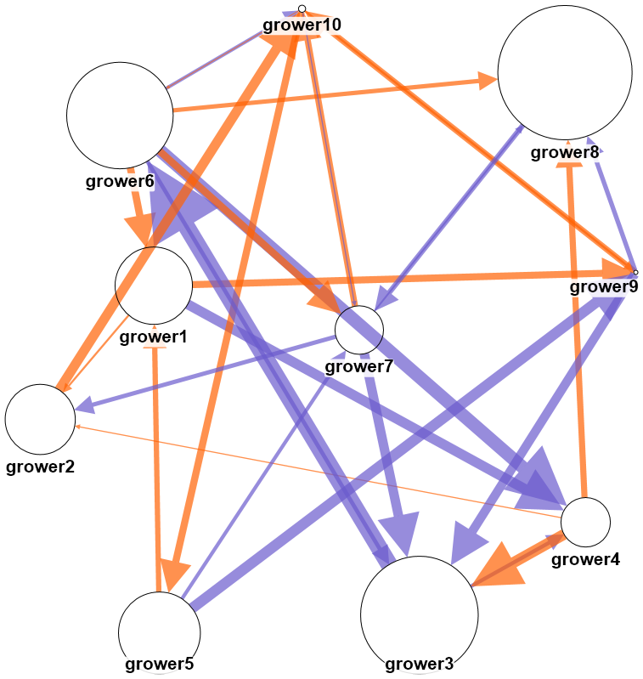
Figure 1b: The pattern of connections leading to the developmental trajectories represented in figure 1a. Blue arrows represent positive (supportive), orange arrows negative (competitive) relationships from one grower to another. The strength of the relationship is represented by the arrows’ thickness. The final level of the growers is represented by the size of the circles. Many relationships are indirect (e.g. a positive relationship from grower 5 to 9 to 3 to 6 to 4)

